Contents:

Talking Points 1
Email / Web Blurbs (Long) 4
Social Media / Ad Blurbs (Short) 5
Web Resources 6

Talking Points

Tsunami Preparedness Week

- Whether you live, work, or travel along the coast, you can participate in California’s Tsunami Preparedness Week this March 22 - 26.

- The official website is TsunamiZone.org, where you can register your participation, find out how to participate, see who is participating, download resources, and view events happening near you.

- Participating in California’s Tsunami Preparedness Week is easy and takes little time: you can create or join a tsunami walk (in-person or virtually through map software such as Google Maps’ Street View); get to know your zone by identifying potential tsunami danger and safe zones; or attend a public lecture about tsunamis. Visit TsunamiZone.org/howtoparticipate for more ideas.

About Tsunamis and Their Effects

- Tsunamis are a series of waves generated by earthquakes, landslides, volcanic eruptions, and meteorites crashes.

- Tsunamis can be large or small, and at their worst are large walls of water that may rapidly flood coastal areas. The waves of a significant, big tsunami may arrive for hours or days.

- The potential height of tsunami waves is a considerable factor but so is how far inland they may flood. Tsunamis can also travel into rivers, bays, harbors, and other bodies of water near the ocean.

- Tsunamis also create strong currents that can disrupt recreational and commercial activities, from fun everyday coastal activities such as kayaking or swimming to crucial shipments our industries rely upon.
- The waves of tsunamis can bring debris and other objects with them that be harmful, such as boats, docks, and chemicals, and some objects may even be on fire.

- Tsunamis can be catastrophic in the short and long-term, affecting millions of people over wide geographical areas, up to many thousands of miles away from the source.

Protective Actions and Preparedness

- Whether you live, work, or play near the coast, you should know how to protect yourself from a tsunami. If you feel any shaking while along the coast, be safe not sorry: you should immediately:

- Drop, Cover, and Hold On, until shaking reduces so that you can safely get up and walk…
- Evacuate to higher ground or inland, or to your known tsunami safe area
- Stay there until emergency officials tell you it is safe to return.

- However, if the tsunami source is distant (thus, you felt no shaking), you may have hours before the initial waves arrive. Follow directions and alerts from emergency responders or other officials and evacuate to a tsunami safe area if needed.

- Before the next tsunami, prepare to survive and recover by following the Seven Steps to Earthquake Safety. Secure your furniture and other items so they don’t fall during earthquake shaking. Identify a safe evacuation area and practice your route to get there often. Think about who your in-state and out-of-state contacts will be and talk with them to make sure they know and understand the various possibilities. Organize your disaster supplies in your home, workplace, and car, and include a go-kit with your essentials should evacuation need to be immediate. Talk to your agent about flood insurance if you live in a tsunami zone.

- Take part in tsunami walks, attend public lectures, and get to know your zone – always be vigilant and willing to learn more!

- Help your community be safer from tsunamis with the U.S. National Weather Service (NWS) "TsunamiReady" program! Through the process, you will gain a better understanding of your tsunami hazard, develop evacuation maps, and establish new contacts (such as local NWS friends!): weather.gov/TsunamiReady/become.

Historical Tsunamis

- Our state’s last significant tsunami was the 2011 M9.0 Tohoku (Japan) Earthquake’s Tsunami which caused more than $100 million in damages to our coast. The first waves arrived to California’s coastline within 10 hours and continued for more than 24 hours period. The 1 death was from a person who went to take photos at the Crescent City harbor and was overtaken by one of the waves. The Crescent City and Santa Cruz harbors were destroyed, with minor damage to harbors reported elsewhere around the state. Flooding occurred in some other low-lying coastal cities.

- The 2010 M8.8 Chile Earthquake’s Tsunami caused severe damage too, though not as much as the 2011 Tohoku Earthquake and Tsunami because it was less powerful. Out of the series of waves that arrived to our shores, the biggest was 4-5 hours after the first. Waves arrived for an 8-hour period overall. Flooding occurred in some low-lying coastal cities.

- Further back in our history, 100 years and more, we have records of local, highly-damaging tsunamis, such as the 1700 Cascadia earthquake and tsunami and the 1812 Santa Barbara tsunami.

Tsunami Warnings

- Natural warning signs a tsunami could be imminent include shaking felt at the coast, the ocean rising or falling unusually, or hearing a loud roar from the ocean. Trust your gut, and remember, it’s always better to be safe than sorry. Get to high ground (100 feet up) or 2 miles inland as soon as possible.

- Our nation’s tsunami warning centers may also issue tsunami alerts. You may get these alerts directly to your cell phone as a Wireless Emergency Alert, or if you signed up to receive SMS notifications from the tsunami warning centers’ Twitter accounts, that way as well. Here are the message definitions:
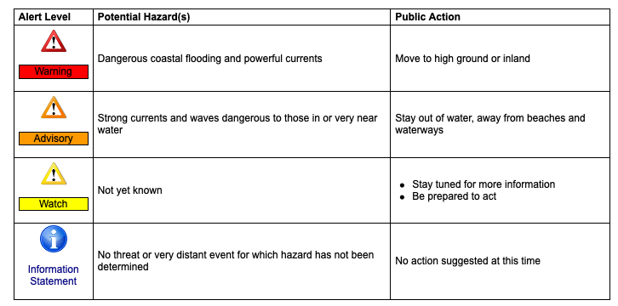

- Your city, county, state, and regional emergency management agencies will also work together to push these alerts to you from the nation’s tsunami warning center.

Email / Web Blurbs (Long)

- Get involved in California’s Tsunami Preparedness Week, March 22 - 26, whether you live, work, or travel along the coast. Individuals, families, workplaces, schools, colleges, and other organizations are encouraged to participate by organizing and registering a tsunami preparedness activity. Consider joining a tsunami walk, participating in a boat evacuation drill, organizing your disaster kits, attending a lecture, and much more. However, these are just suggestions. You, your community, and organization can do many things to learn more about tsunamis and be better prepared.

At TsunamiZone.org, you can learn how to participate and register your activity. Registered participants can learn more about what they can do to get prepared through flyers, guides, and informational brochures. Participants also receive news and preparedness tips through TsunamiZone.org email updates, and above all, serve as an example to others to participate and prepare. Don’t forget to use #TsunamiPrep!

- Are you in the zone? Find out if you live, work, or travel in a tsunami hazard zone at TsunamiZone.org/knowyourzone, where you can try Cal OES’ “MyHazards” tool or access the California Geological Survey’s tsunami inundation maps.

Consider registering a tsunami preparedness activity or participating in one for California’s Tsunami Preparedness Week, this March 22 - 26 (#TsunamiPrep!). From practicing a tsunami walk to creating a family communications plan there are many things you, your community, and/or organization can do to be better prepared. Register yourself and your activity at TsunamiZone.org to receive news and tips and be counted as a participant in this year’s activities!

- Mark your calendars! California’s Tsunami Preparedness Week is March 22 - 26. The Golden State can experience a tsunami at any time. Would you know what to do? Whether you live, work, or travel along the coast, you should know how to protect yourself in case of a tsunami. More than 100,000 are already registered to participate this year, join us: TsunamiZone.org. Be sure to use #TsunamiPrep in your social media posts too!

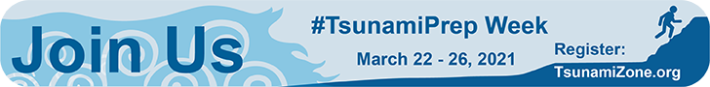

Get graphics for all your needs at TsunamiZone.org/graphics!

Social Media / Ad Blurbs (Short)

Graphics shown are optimized for Twitter. For other social media platforms and needs: see TsunamiZone.org/graphics.

- Join us and thousands of Californians in getting prepared for tsunamis during #TsunamiPrep Week (22 - 26): TsunamiZone.org

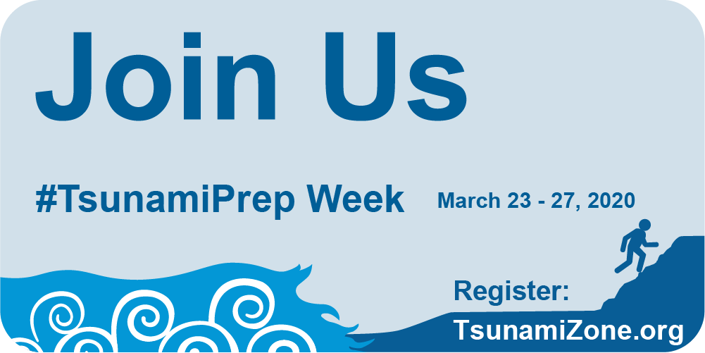

- Do you know your zone? Find out and get involved in California’s #TsunamiPrep Week (22 - 26): TsunamiZone.org

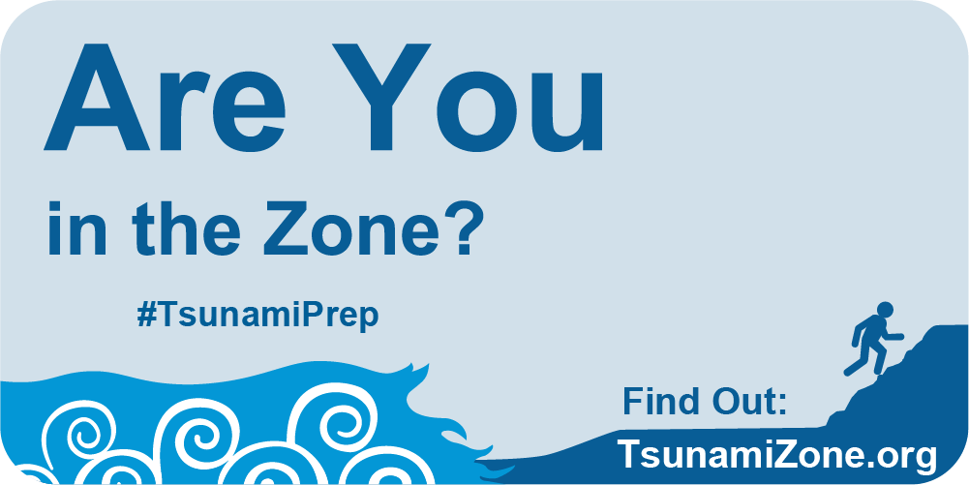

- The California Geological Survey has tsunami inundation maps for anyone to view, get to know your zone: http://www.conservation.ca.gov/cgs/geologic_hazards/Tsunami/Inundation_Maps/Pages/Index.aspx? #TsunamiPrep

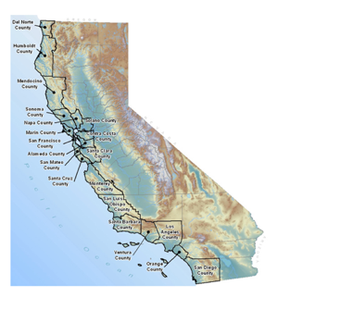
- Flood insurance is the only type of insurance that covers damage from a tsunami. Know your zone: http://www.FloodSmart.gov #TsunamiPrep

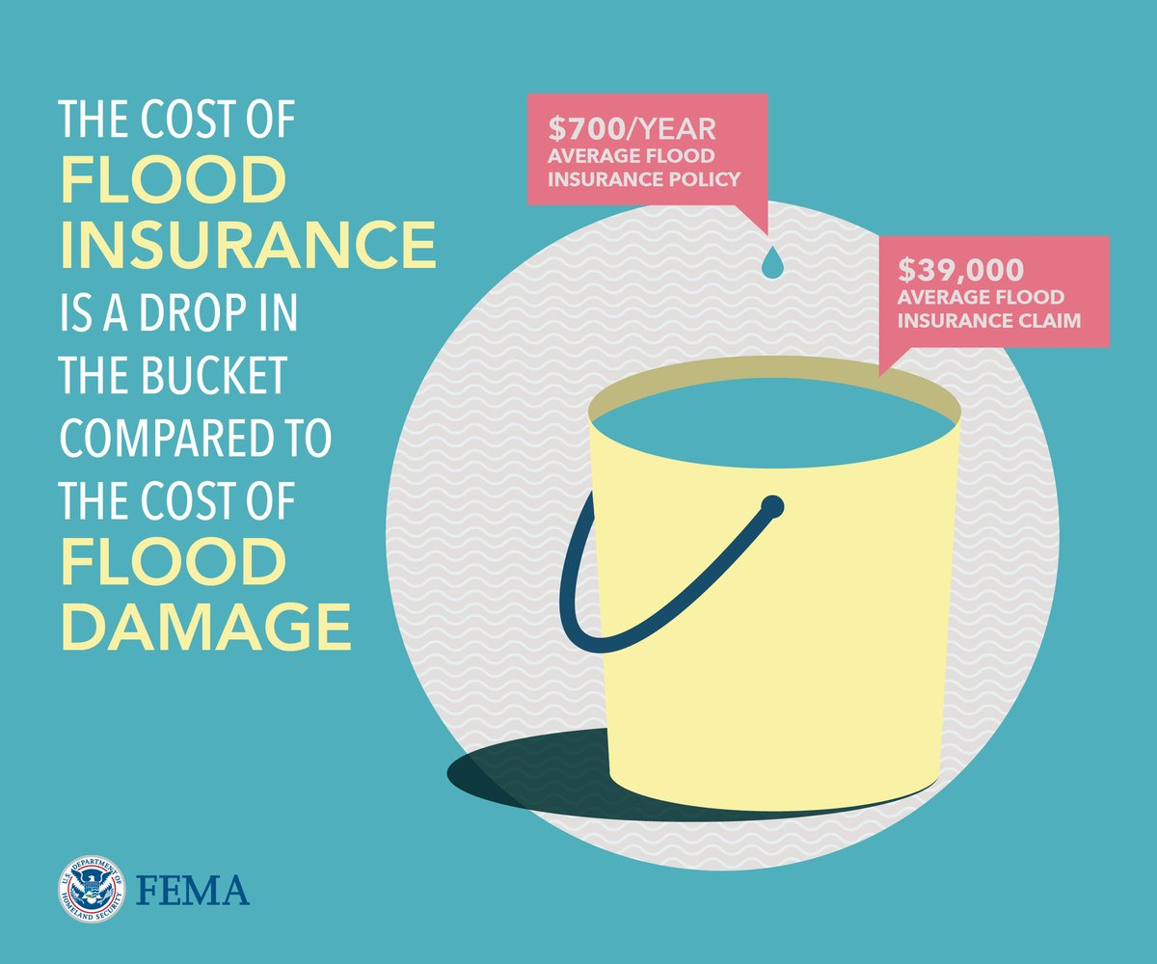

Get graphics for all your needs at TsunamiZone.org/graphics!

Web Resources

- TsunamiZone.org California page: TsunamiZone.org/california
- Web banners, tsunami safety graphics, and posters: TsunamiZone.org/graphics/
- California inundation maps, “MyHazards” tool: TsunamiZone.org/knowyourzone
- Safety guides, tsunami walk instructions, and education materials: TsunamiZone.org/resources
- Register your activity: TsunamiZone.org/register
- See who else is participating: TsunamiZone.org/whoisparticipating
- How to participate: TsunamiZone.org/howtoparticipate
- Submit a public/media event: TsunamiZone.org/calendar

Contact
Email: info@tsunamizone.org
Phone: 213.740.3260

